**Project Name:**

**Property Management Application Using Salesforce - (Developer) - (Short-Term)**

**INTRODUCTION:**

Develop an App for the Property Management where Buyer can order his Requirements and get the Appropriate Details of the Property. According to his interest just provide him with some discounts up to what extent he can get the discount. Also Track Whether he is Interested in taking the loan available for so just calculate how much loan Amount user can get it. Provide the Security for two different profiles like for marketing and sales team. Then Finally Create the reports and dashboard so there will be clear view just get the reports on the count of loan passed getting the property purchased close the deal.

**MILESTONE – 1**:

**SALESFORCE**

**Creating Developer Account**

* Creating Developer Account
* Creating Developer Account
* Creating a developer org in salesforce.
* Go to developers.salesforce.com/Click on sign up.
* On the sign up form, enter the following details :
* First name & Last name : sunkarla Varun Kumar
* Email: varunkumar611977@gmail.com
* Role : Developer
* Company : Gayatri Degree College
* County : India
* Postal Code : 517501
* Username :propertymanage@gdcproject.com
* Click on sign up after filling these.

**Account Activation**

1.Go to the inbox of the email that you used while signing up. Click on the verify account to activate your account. The email may take 5-10mins, as

2.Login To Your Salesforce Account

**MILESTONE-2**

**Object**

What Is Object?

Salesforce objects are database tables that permit you to store data that is specific to an organization. What are the types of Salesforce objects

Salesforce objects are of two types:

1.Standard Objects: Standard objects are the kind of objects that are provided by salesforce.com such as users, contracts, reports, dashboards, etc.

2.Custom Objects: Custom objects are those objects that are created by users. They supply information that is unique and essential to their organization. They are the heart of any application and provide a structure for sharing data.

**Custom Objects - Enquiry, Property, Loan**

Objects-Enquiry, Property, Loan,

Create Enquiry Object

Custom

To Navigate to Setup page

To create an object:

To create an object:

From the setup page ? Click on Object Manager ? Click on Create ? Click on Custom Object.

On Custom object defining page:

Enter the label name (lead), plural label name ?(leads), Record name(Customer Name)

Click on Allow reports, Allow search ? Save

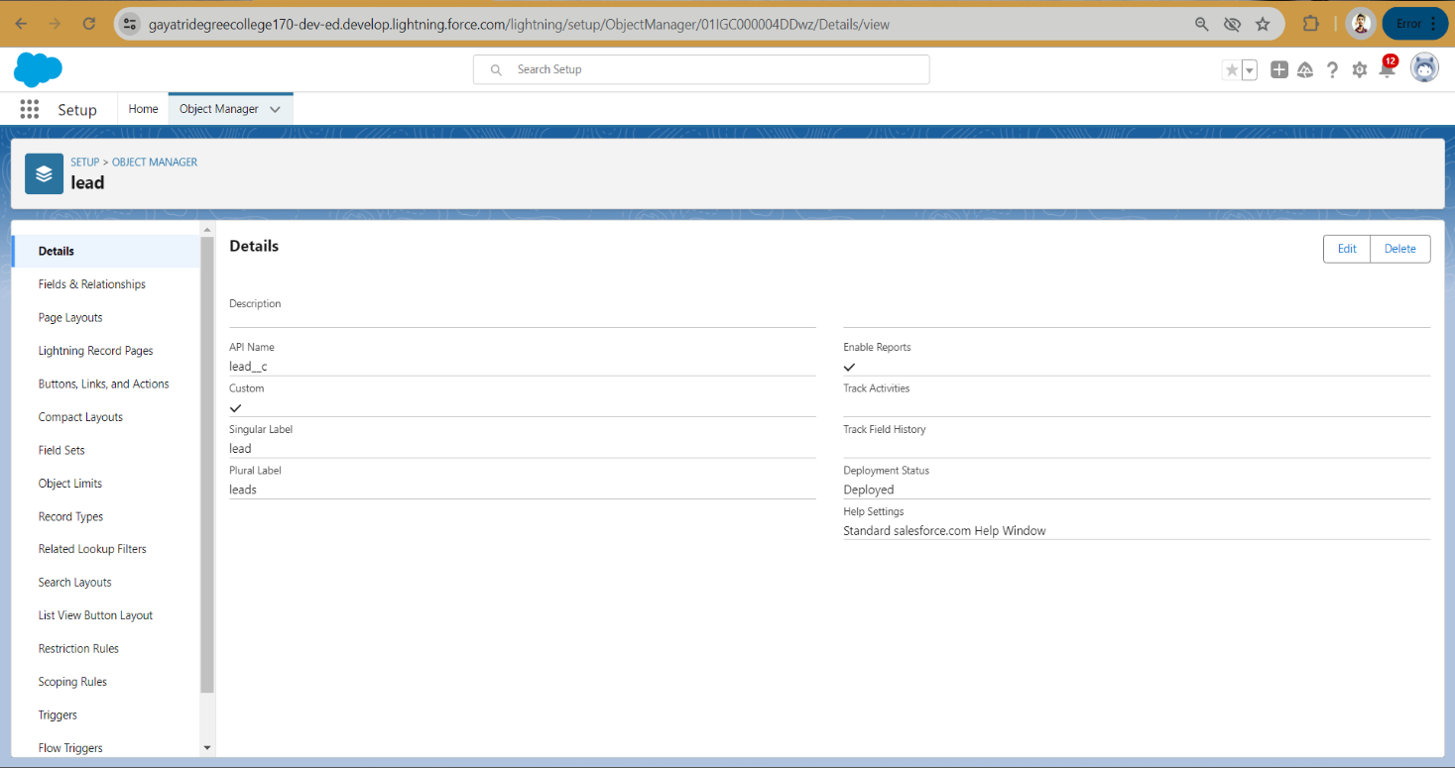

**Create Object Property**

1)To create an object:

2)From the setup page ? Click on Object Manager ? Click on Create ? Click on Custom Object.

3)Enter the label name?Property

4)Plural label name? Properties

5)Record Name?Property Name

6)click on Allow reports,

7)Allow search ? Save

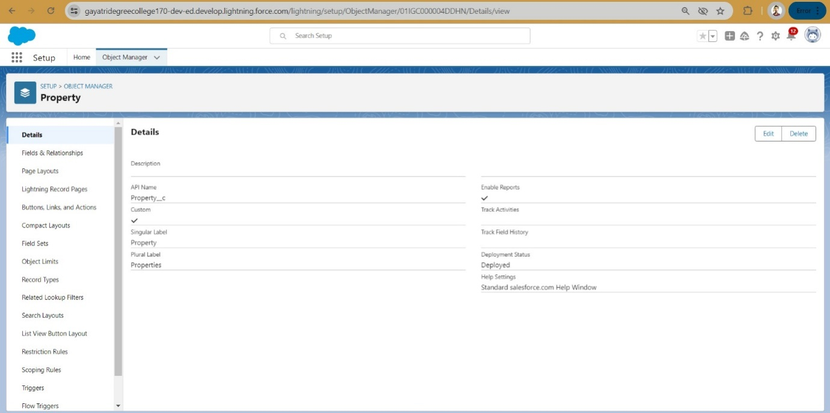

**Create Object Loan**

1.To create an object:

2.From the setup page ? Click on Object Manager ? Click on Create ? Click on Custom Object.

3.Enter the label name?Loan

4.plural label name? Loans

5.Record Name?Loan Id

6.Data Type?Auto Number

7.Display Formate?LN-{0000}

8.Starting Number?0001

9.click on Allow reports,

10.Allow search?Save

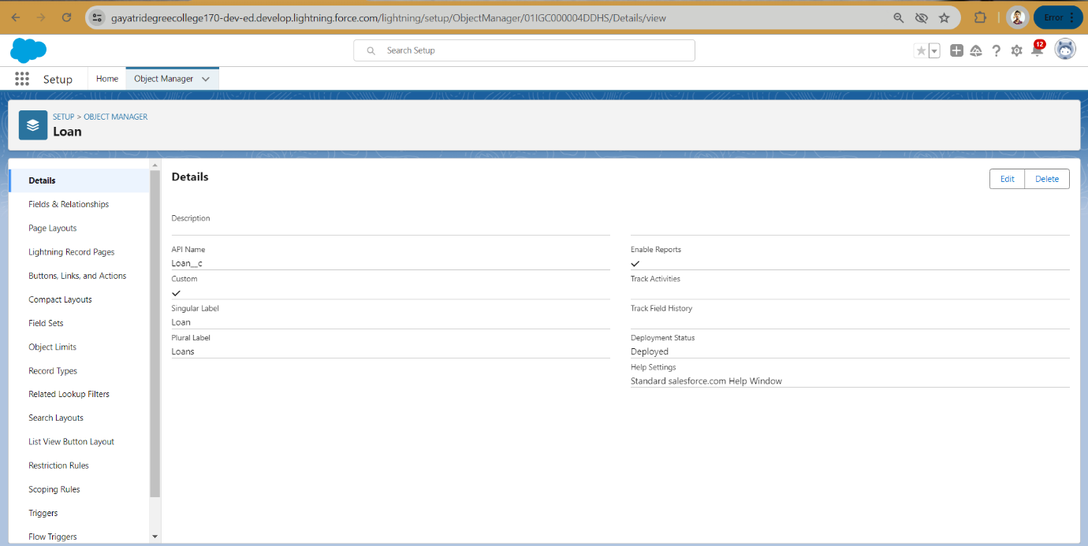

**MILESTONE-3**

**Tab**

What is Tab?

A tab is like a user interface that is used to build records for objects and to view the records in the objects.

1.Types of Tab

2.Custom object tab

3.Web tab

4.Visualforce tab

**Create The Lightning Tab**

Create the Lightning Tab to create a Tab:(enquiries)

Go to setup page ? type Tabs in Quick find bar ? click on tabs ? New (under custom object tab)

Select Object(Lead) ? Select the tab style ? Next (Add to profiles page) keep it as default ? Next (Add to Custom App) keep it as default ? Save.

**Create A Tab ( Property,Loan )**

**To create a Tab:(Property)**

1)Go to setup page ? type Tabs in Quick Find bar ? click on tabs ? New (under custom object tab)

2)Select Object(Property) ? Select the tab style ? Next (Add to profiles page) keep it asdefault ? Next (Add to Custom App) keep it as default ? Save.Activity4:

**To create a Tab:(Loan)**

1)Go to setup page ? type Tabs in Quick Find bar ? click on tabs ? New (under custom object tab)

2)Select Object(Buy) ? Select the tab style ? Next (Add to profiles page) keep it as default ? Next (Add to Custom App) keep it as default ? Save

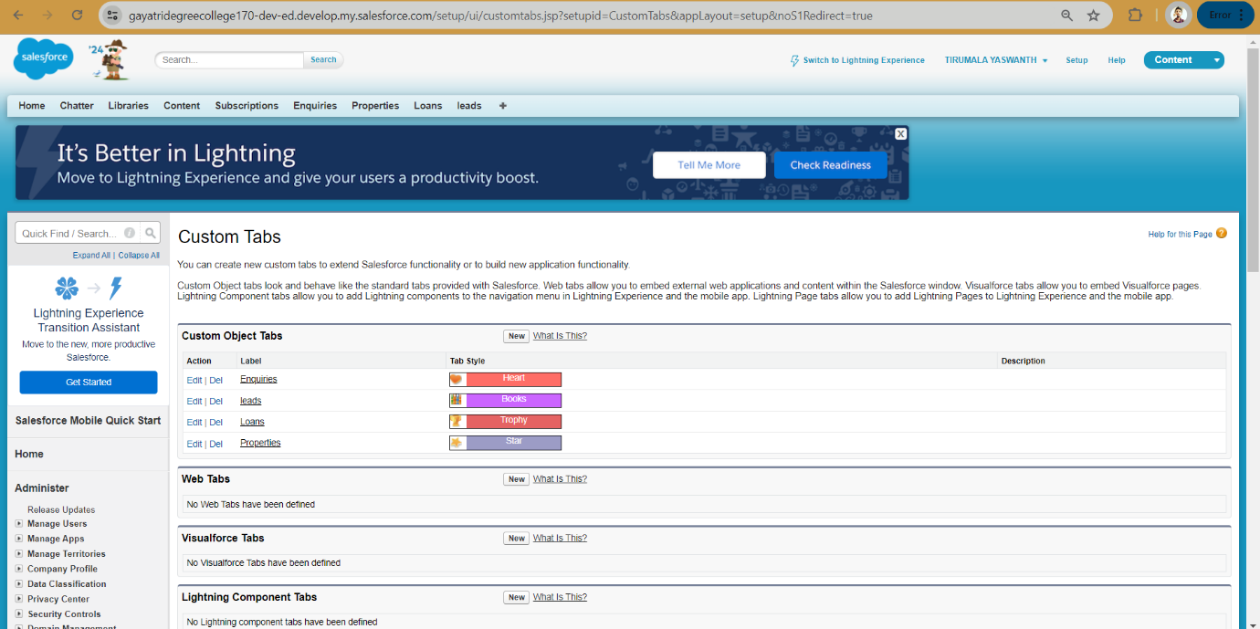

**MILESTONE-4**

**The Lightning App**

An app is a collection of items that work together to serve a particular function. In Lightning Experience, Lightning apps give your users access to sets of objects, tabs, and other items all in one convenient bundle in the navigation bar.

Lightning apps let you brand your apps with a custom color and logo. You can even include a

utility bar and Lightning page tabs in your Lightning app. Members of your org can work more efficiently by easily switching between apps.

Create the Lightning App

Go to setup page ? search “app manager” in quick find ? select “app manager” ? click on New lightning App.

Fill the app name as an Property Management in app details and branding ?Next ? (App option page) keep it as default ? Next

(Utility Items) keep it as default ?Next ? (Add User Profile) Add System Administrator, Salesforce platform user, Standard User ? Next.

To Add Navigation Items:

( Lead, Property, Loan, Report, Dashboard) Select the items from the search bar and move it using the arrow button ? Next.

To Add User Profiles:

( System Administrator, Salesforce platform user, Standard User)

Search profiles in search bar ? click on the arrow button ? save & finish.

**Create The Lightning App**

Go to setup page ? search “app manager” in quick find ? select “app manager” ? click on New lightning App.

Fill the app name as an Property Management in app details and branding ?Next ? (App option page) keep it as default ? Next

(Utility Items) keep it as default ?Next ? (Add User Profile) Add System Administrator, Salesforce platform user, Standard User ? Next.

To Add Navigation Items:

( Lead, Property, Loan, Report, Dashboard) Select the items from the search bar and move it using the arrow button ? Next.

To Add User Profiles:

( System Administrator, Salesforce platform user, Standard User)

Search profiles in search bar ? click on the arrow button ? save & finish

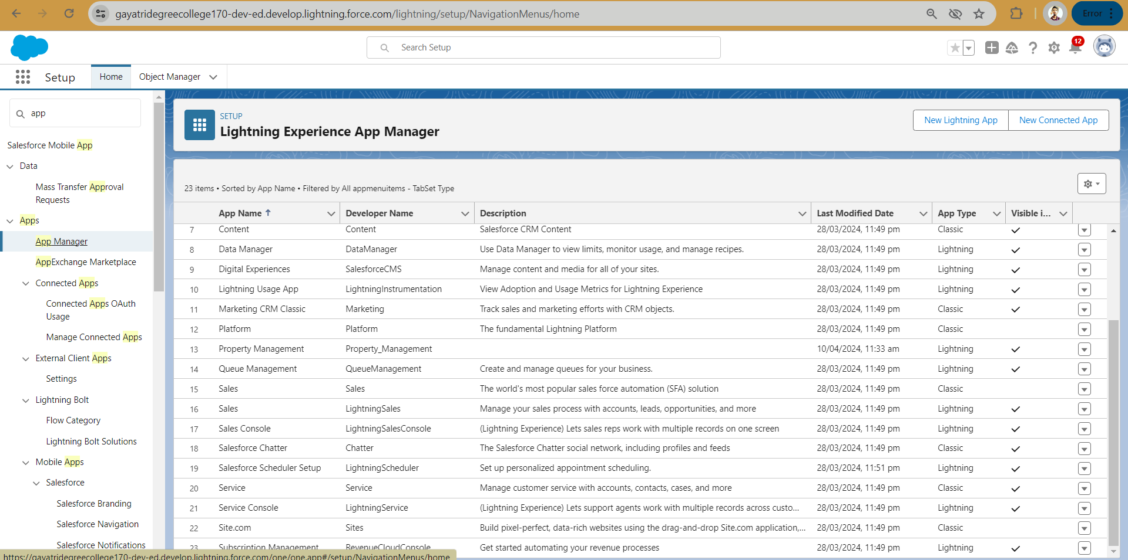

**MILESTONE-5**

**Fields**

When we talk about Salesforce, Fields represent the data stored in the columns of a relational database. It can also hold any valuable information that you require for a specific object. Hence, the overall searching, deletion, and editing of the records become simpler and quicker.

1.Types of Fields

2.Standard Fields

3.Custom Fields

**Fields Standard**:

As the name suggests, the Standard Fields are the predefined fields in Salesforce that perform a standard task. The main point is that you can’t simply delete a Standard Field until it is a non- required standard field. Otherwise, users have the option to delete them at any point fromthe application freely. Moreover, we have some fields that you will find common in every Salesforce application. They are,

1.Created By

2.Owner

3.Last Modified

**Custom Fields:**

On the other side of the coin, Custom Fields are highly flexible, and users can change them according to requirements. Moreover, each organizer or company can use them if necessary. It means you need not always include them in the records, unlike Standard fields. Hence, the final decision depends on the user, and he can add/remove Custom Fields of any given form.

**Create Fields**

1. Go to setup ? click on Object Manager ? type object name in search bar ? click on the object

2.Now click on “Fields & Relationships” ? New.

Select Datatype (Auto number)

1. Fill the field label name Lead Number, Datatype (autonumber) ?Next ?Next ? Save.
2. Create the remaining Fields:

Follow the above activity 1 Steps 1 to 2, create the Field just change the Labels and data types for Below Fields

**Create picklist fields on enquiry object**

Create picklist fields on enquiry object

Click on the gear icon and then select Setup.

Click on the object manager tab just beside the home tab.

After the above steps, Select enquiry Object

Now Select Fields and relationships from setup menu of the enquiry object.

Click new and select Picklist fields ????next and enter label name(State) and select enter values option((Maharashtra, Gujarat, Rajasthan),next and Save

Note: we create picklist fields for city follow the above steps just change the Labels and values.

Create Field Dependency(on enquiry objects)

Create a dependency between these two picklists, so that when a state is selected, only respective Values are available.

The below steps will assist you in creating Field Dependencies.

Click on the gear icon and then select Setup.

Click on the object manager tab just beside the home tab.

After the above steps, Select enquiry Object

Now Select Fields and relationships from setup menu of the enquiry object.

Click Field Dependencies.

Click New.

Select State as the Controlling Field and select City as the Dependent Field.

Click Continue.

Select the appropriate Value in each column by double-clicking them.

Maharashtra:i) Nashik

Click Include Values. And it is also same for Gujarat & Rajasthan with its city.

Click Preview, then test the dependency by selecting different State and viewing the associate Values available for Particular state.

Click Close to close the preview window.

Click Save.

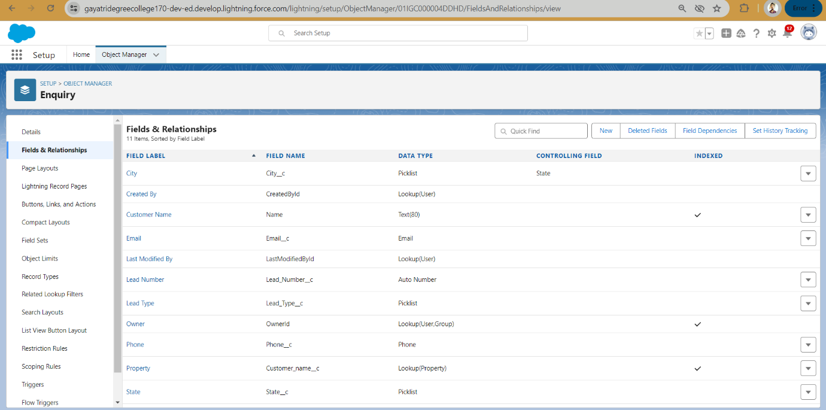

**For Property Object**

Create the remaining Fields**:**

Follow the above activity 1 Steps 1 to 2, create the Field just change the Labels and data types for Below Fields.

1.Customer name (lookup relationship related to Enquiry)

2.Create Property Type: (Picklist fields) (Residential, Commercial, Industrial) (Field Dependency)

3.Residential: Picklist fields (1BHK, 2BHK, 3BHK) (Field Dependency)

4.Commercial: Picklist fields (Shop, Office) (Field Dependency)

5.Industrial: Picklist fields (Factory, Mall) (Field Dependency)

Note: In above picklist fields Property type is control field and Residential, Commercial, Industrial is dependent field

6.State: Create the Picklist Field (Maharashtra, Gujarat, Rajasthan)(Field Dependency)

7.City:(Take Any City for Field Dependency)

Note: In above picklist fields State is a control fields and city is dependent field

8.Discount:(Percentage As the Field Data Type)

9.Price: (Number As the Field Data Type)

10.Loan Amount: (Currency As the Field Data Type)

For the Property Object? Go to the fields and Relationship and select the formula in field data type. In Formula option select Advanced Formula and write the followingformula.

Lead_Idr.Customer_Name c

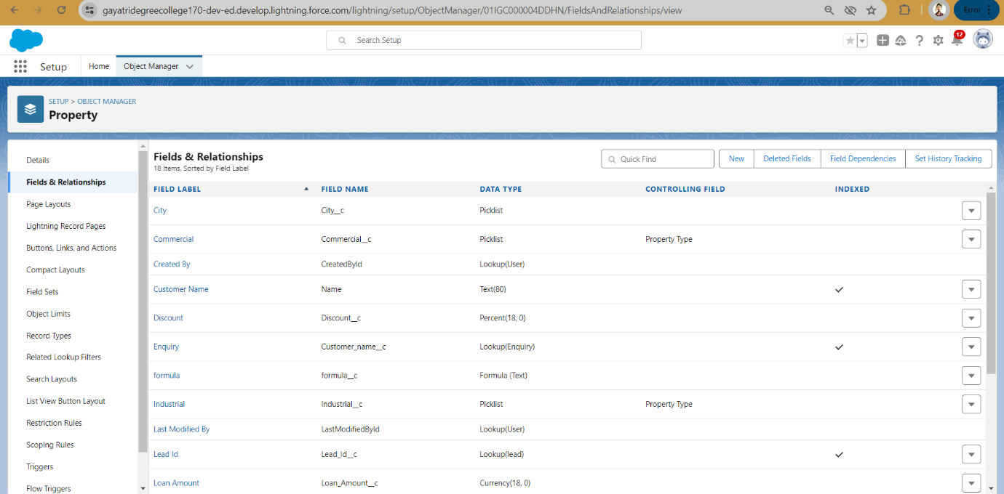

**For Loan Object**

Create the remaining Fields:

Follow the above activity 1 Steps 1 to 2, create the Field just change the Labels and data types for

Below Fields

1. Property name: (lookup relationship related to property)

2. Customer name: (lookup relationship related to Enquiry)

3. Interest Rate: (Select the Field Data Type As Currency)

4. Term: (Select the Field Data type as Number)

5. Annual Loan: Field create the Number as the field data type

6. Total Loan Installments: ( Field create the Number as the field data type)

7. Loan Repayment: ( Field create the Number as the field data type)

8. Loan Amount: (Select the Field data type as Formula)

For the Loan Object? Go to the fields and Relationship and select the formula in

field data type. In Formula option select Advanced Formula and write the following

formula

(Loan_Repayment__c* (((1+( Interest_Rate__c/52))^Term__c) -1))/((

Interest_Rate__c/52)*((1+( Interest_Rate__c/52))^ Term__c))

##Check the syntax below whether the formula syntax is correct or not

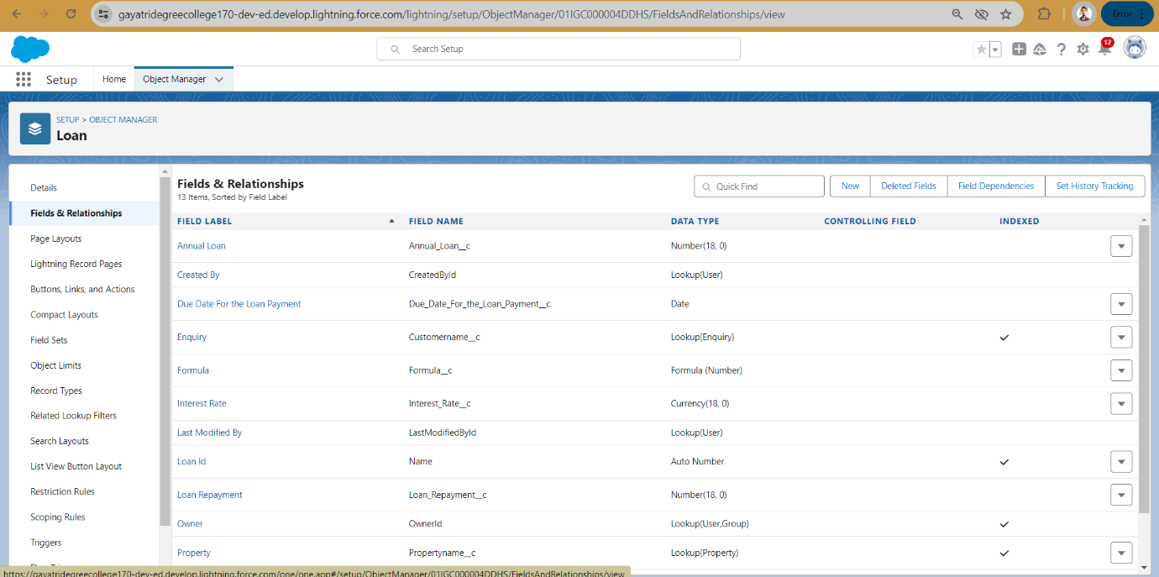

**MILESTONE-6**

**Page Layout And Record Type**

Page Layout in Salesforce allows us to customize the design and organization of detail and edit pages of records in Salesforce. Page layouts can be used to control the appearance of fields, related lists, and custom links on standard and custom object detail and edit pages.

Record types in Salesforce allow you to have different business processes, picklist values, and page layouts to different users based on profile.

**Create Page Layout For Property Object**

Create a page layout for Property Object

Go to setup ? click on Object Manager ? type object name in search bar ? click on the object

Now click on “Page Layout” ? New.

### Rent Page Layout

### Create another page layout name as (Rent) with the help of above steps of activity 1. And remove the discount and loan amount fields from the rent page layout

### Record Type For Property Object

Go to setup ? click on Object Manager ? type object name in search bar ? click on the object  
Now click on “Record type ” ? New.

Enter the record type label as (Buy) and selective active checkbox next and save

### Record Type Rent

### Create report type name has Rent with the above steps of activity-3

### Page Layout Assignment

* Go to setup ? click on Object Manager ? type object name in search bar ? click on the object
* Now click on “page layout ” ? click page layout assignment
* Select the buy record type and select page layout to use(buy) then click on save.

### Page Layout Assignment For Rent

### Follow above 1 to 3 steps We assign rent page layout for rent record type.

### 

### MILESTONE-7

### Profile

* A profile is a group/collection of settings and permissions that define what a user can do in salesforce.
* Profile controls “Object permissions, Field permissions, User permissions, Tab settings, App settings, Apex class access, Visualforce page access, Page layouts, Record Types, Login hours & Login IP ranges.
* You can define profiles by the user's job function. For example System Administrator, Developer, Sales Representative.

### Types of profiles in salesforce

### Standard profiles:

* By default salesforce provide below standard profiles.
* We cannot deleted standard ones
* .Each of these standard one includes a default set of permissions for all of the standard objects available on the platform.

### Custom Profiles:

### Custom ones defined by us. They can be deleted if there are no users assigned with that particular one.

### Create A New Profile

To create a new profile:

### Go to setup ? type profiles in quick find box ? click on profiles ? clone the desired profile (standard user is preferable).

### Enter a Profile Name(Sales Manager) And click on Save

### Click on the new created profile

### While still on the profile page, then click Edit.

### Scroll down to Custom Object Permissions and Give view all access permissions for Lead, Property, Loan and save(Sales Manager also Having Create, Edit, Delete for Lead, property, loan objects)

6.Create Remaining Profiles

Follow the Above Steps to create the Profile just change the Name for below profiles Clone profile (Standard Platform User) for below all profiles

(a). Marketing Executive profile (b). Marketing Manager profile

### Create Marketing Executive Profile

Create Marketing Executive Profile

1.Then In The Profile Level Give Read and Create Access for Lead, property, loan objects to Marketing Executive profile and Read, Create, Edit, Delete for the Marketing manager profile for Lead, property, loan objects  
2.Marketing Manager profile Should Have Access to Marketing Executive profile

### Create Sales Executive Profile

Activity3- Create Sales Executive Profile:  
 Follow the Above Steps to create the Profile just change the Name for Below profiles clone profile (StandardPlatform User) ,profile name (Sales executive profile).  
And assign a sales rep1 permission set  
For Sales Rep1? Read, Create, Edit for lead, property and loan objects. For Sales Rep3? Read only.  
  
Note: above 2 are permission set and assign a permission set according to user need. We will discuss in next milestone.

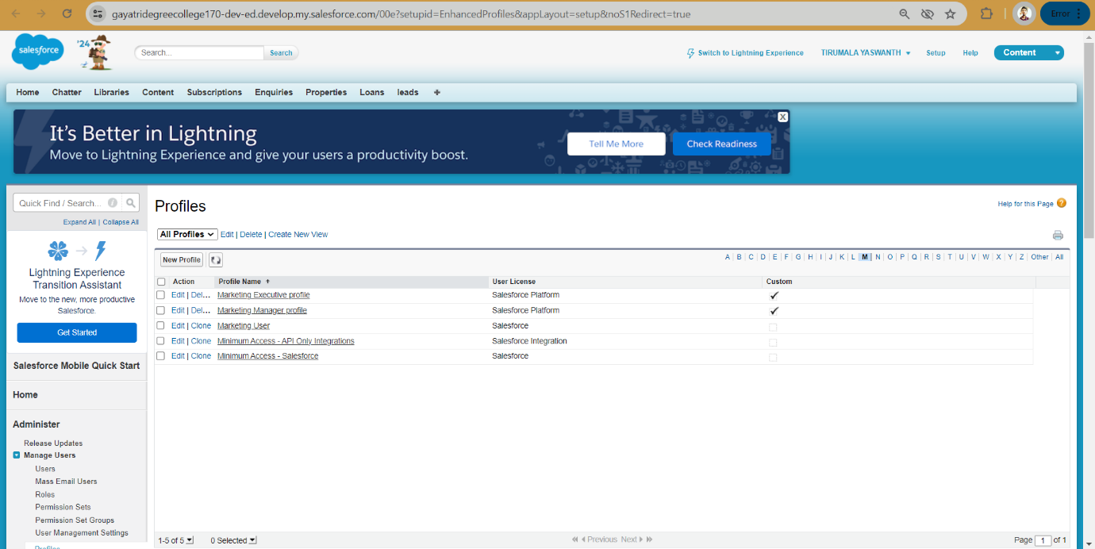

**MILESTONE-8**

User

* A user is anyone who logs in to Salesforce. Users are employees at your company, such as sales reps, managers, and IT specialists, who need access to the company's records.
* Every user in Salesforce has a user account. The user account identifies the user, and the user account settings determine what features and records the user can access.

**NOTE-**As Salesforce license can only be used by 2 Users at a time in Dev Org,so If you don’t find salesforce license then deactivate a user who has salesforce license Or change the license type from Salesforce to any other.

### Create User

### Go to setup ? type users in quick find box ? select users ? click New user.

### First Name: Sunny Last Name: Gupta Alias: Sanj Email: provide your personal email id for future reference Username: sunnygupta@thesmartbridge.com Nickname: Sunny Role: leave it as default User License: Salesforce Profile: Sales Manager and Click Save Button. Note: Assign Profile according to user requirement.

### MILESTONE-9

**Permission Set**

A permission set is a collection of settings and permissions that give users access to various tools and functions. Permission sets extend users' functional access without changing their profiles. Users can have only one profile but, depending on the Salesforce edition, they can have multiple permission sets.

### Create Permission Set

### 1.Go to setup ? type “permission sets” in quick search ? select permission sets ? New

### 2.Enter the label name (Sales Rep Advance) ? save

### 3.Select Object settings

### 4.Search object property and select property object. and click Edit button

### 5.In Object Permission we give View all permission. And click save button

6.Repeat 4th and 5th steps for Enquiry and Loan objects.

7.After saving the permission click on the Manage assignment

8.Now click on the Add Assignment

9.Now select the user (sunny) and click on next & assign.

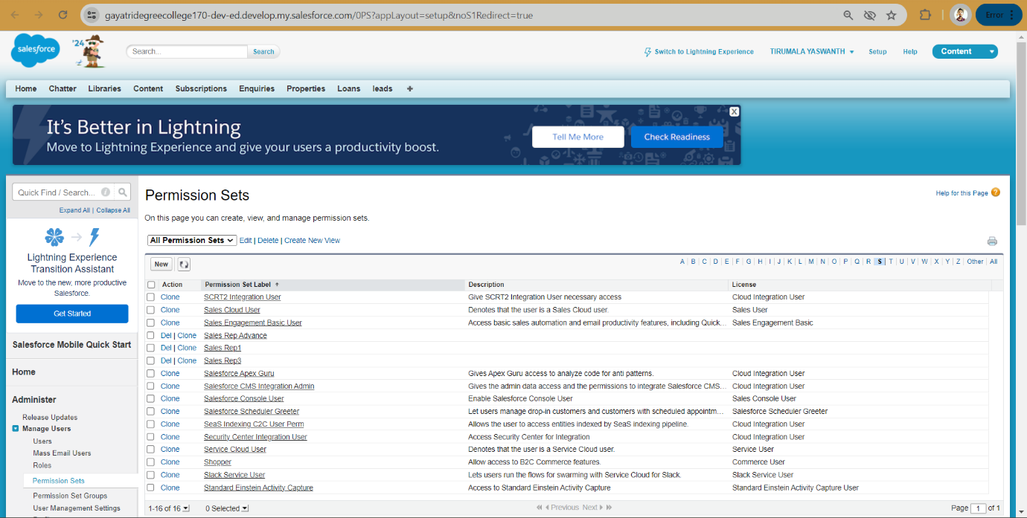

**MILESTONE-10**

### Set Up For OWD

### Organization-Wide Defaults, or OWDs, are the pattern security rules that you can follow for

### your Salesforce instance. Organization Wide Defaults are utilized to confine who can access what information in your CRM. You can award access through different methods that wewill discuss later (sharing principles, Role Hierarchy, Sales Teams, and Account groups,manual sharing, and so forth).

Primarily, there are four levels of access that can be set in Salesforce OWD and they are-

1. Public Read/Write/Transfer (only available of Leads and Cases)
2. Public Read/Write
3. Public Read/Only
4. Private

### Create OWD Setting

### 1.Setup, use the Quick Find box to find Sharing Settings. 2.Click Edit in the Organization-Wide Defaults area. 3.For each object, select the default access you want to give everyone. 4.To disable automatic access using your hierarchies, deselect Grant Access Using Hierarchies for Enquiry, Property custom object

5.Click Edit and from the Drop Down select private for internal and external  
6.This Setting is for all the User Which have been Created

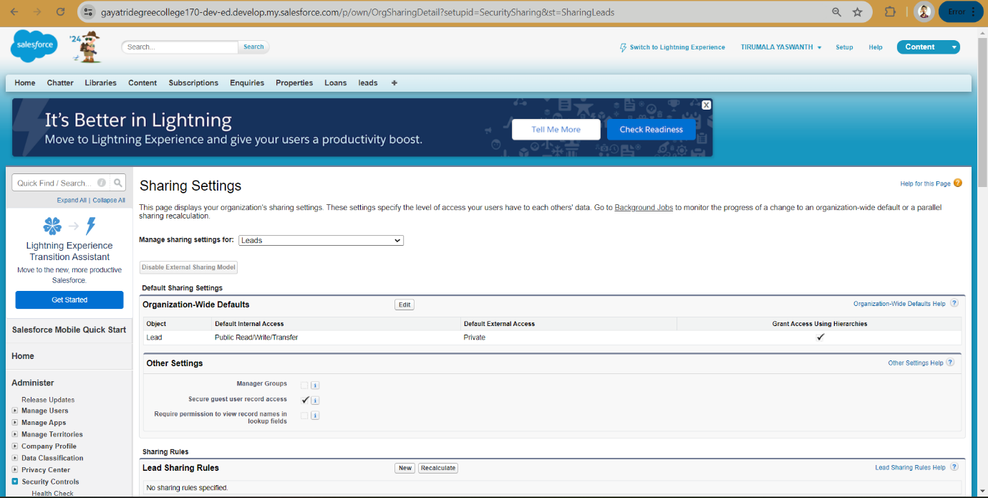**MILESTONE-11**

### User Adoption

### Create A Record(Enquiry)

1. Click on App Launcher on left side of screen.
2. Search Property Management & click on it.
3. Click on Inquiries Tab.
4. Click new and fill details & Save

### View A Record(Enquiry)

1. Click on App Launcher on left side of screen.
2. Search Property Management & click on it.
3. Click on Inquiries Tab.
4. Click on any record name. you can see the details of the Event

### Delete A Record(Enquiry)

1. Click on App Launcher on left side of screen.
2. Search Property Management & click on it.
3. Click on Inquiries Tab.
4. Click on Arrow at right hand side on that Particular record.
5. Click delete and delete again.

**MILESTONE-12**

**Report**

1. Reports give you access to your Salesforce data. You can examine your Salesforce data in almost infinite combinations, display it in easy-to-understand formats, and share the resulting insights with others. Before building, reading, and sharing reports, review these reporting basics.  
      
   Types of Reports in Salesforce

* Tabular
* Summary
* Matrix
* Joined Reports

**Create Report**

1. Go to the app ? click on the reports tab
2. Click New Report
3. Select report type from category or from report type panel or from search panel (properties with customer name) ? click on start report.
4. Customize your report, add fields like property name, customer name, city, property type etc. Click on save& run (Properties with Customer Name Report)
5. Create Report for following Condition
6. Create the Report of the Total Number of Loan Passed for getting the Amount For the Property
7. The Condition should be Like Loan Amount >= to 5000$

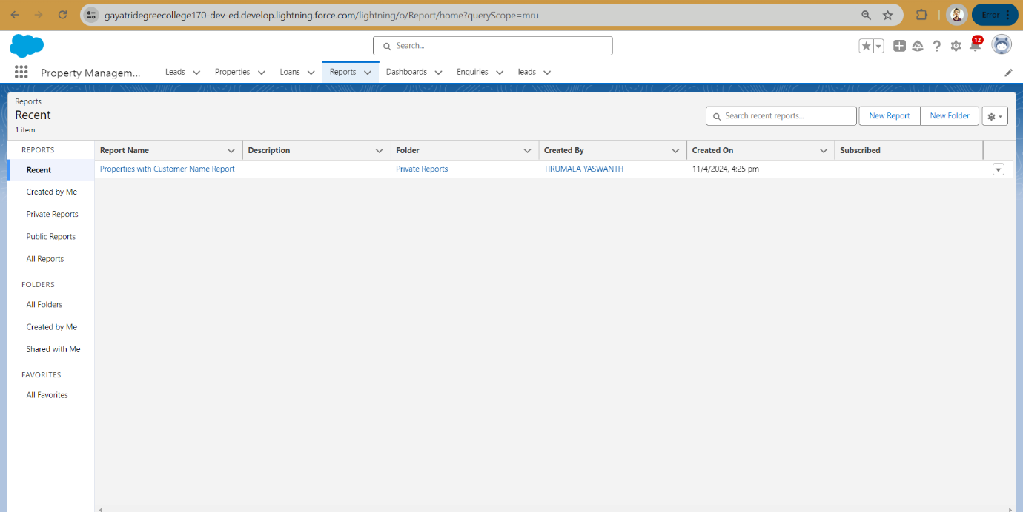**MILESTONE-13**

**Dashboards**

Dashboards help you visually understand changing business conditions so you can make decisions based on the real-time data you’ve gathered with reports. Use dashboards to help users identify trends, sort out quantities, and measure the impact of their activities. Before building, reading, and sharing dashboards, review these dashboard basics.

**Create Dashboards**

1.Click the Dashboards tab.  
2.Click New Dashboard.  
3.Name the Properties with Customer Name Report and click Create.  
4.Click +Component.  
5.Select the Properties with Customer Name Report and click Select

6.Select the Vertical Bar Chart component(select in which format you want display chart and click Add.  
7.Click Save and then Done.

**Create Dashboards**

Follow the above steps  
1.Create the Dashboard for the Same Take Any Type of Dashboard(Chart) And Display Iton The App Home Page

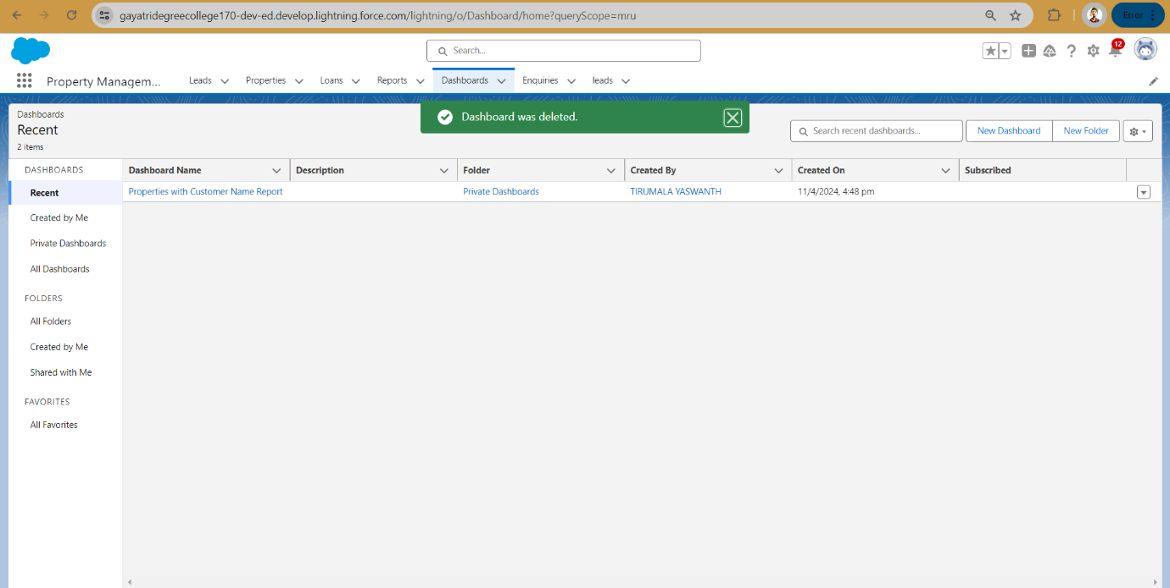

**MILESTONE-14**

View Report And Dashboard

**Report**

1. Click on App Launcher on left side of screen
2. Search property management & click on it.
3. Click on Reports Tab.
4. Click on Properties with Customer Name & see records

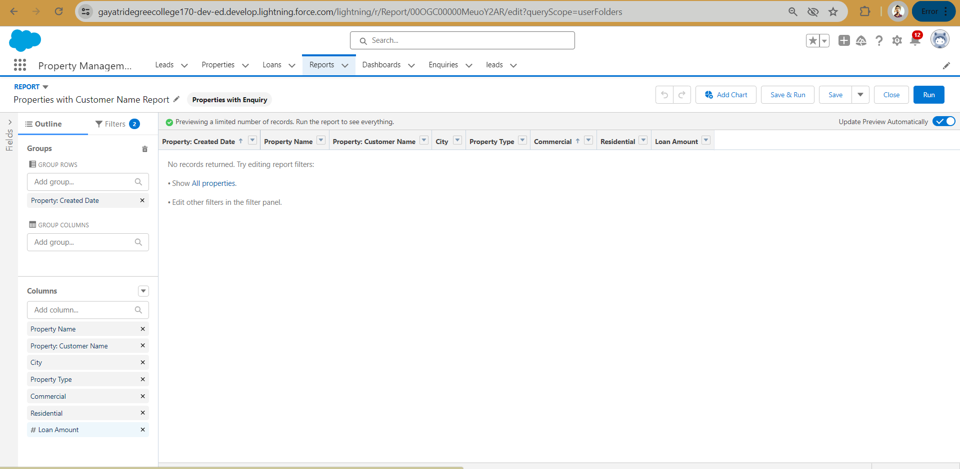

**Dashboard**

Dashboards help you visually understand changing business conditions so you can make decisions based on the real-time data you’ve gathered with reports. Use dashboards to help users identify trends, sort out quantities, and measure the impact of their activities. Before building, reading, and sharing dashboards, review these dashboard basics.

**View Dashboard**

1.Click the Dashboards tab.  
2.Click New Dashboard.  
3.Name the Properties with Customer Name Report and click Create.  
4.Click +Component.  
5.Select the Properties with Customer Name Report and click Select

6.Select the Vertical Bar Chart component(select in which format you want display chart and click Add.  
7.Click Save and then Done.

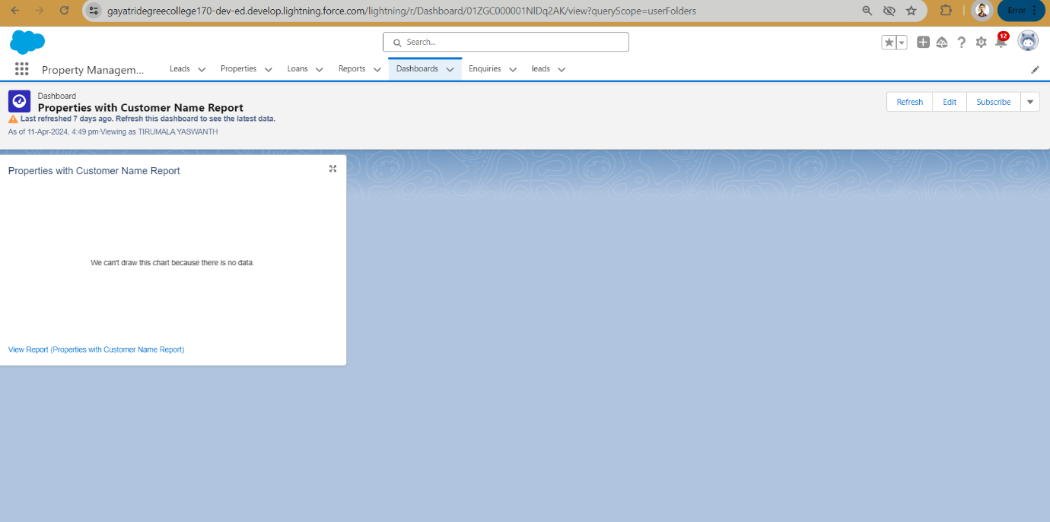

**MILESTONE-15**

**Flow Builder**

Flows In Salesforce, a flow is a tool that automates complex business processes. Simply put, it collects data and then does something with that data.

Flow Builder is the declarative interface used to build individual flows.

Flow Builder can be used to build code-like logic without using a programming language. Flows fall into five categories:

* Screen Flows
* Schedule-Triggered Flows
* Autolaunched Flows
* Record-Triggered Flows
* Platform Event-Triggered Flows

**Classic Email Template**

**Classic Email Template**

**Note**: For creating this flow you have to create the Due date for Loan Payment

field in the loan object with date and time field data type

Go to the Gear Icon?Click on the home button and Search for the Classic Email Template

?Click on the New Template? name?oan Amount Pay Reminder

Author as the System admin user?giveDescription?Reminder Calls through emails

Clone that Email Template and follow the steps which is mentioned above and give the following names you have to clone it multiple times that template

1. Loan Amount pay Reminder for 24 hrs

2. Overdue by one day

3. Overdue

Create The Email Alerts

Click on the home button and search for the Email Alerts  ---> There Click on the New Email alerts

 ---->and give the name as Email For the 24 hrs before---> select the email template which you have

created for the 24 hrs before

There Click on the New Email alerts---->  and give the name as Email For the 24 hrs before

---->select the email template which you have created for the 24 hrs before and recipient

for all condition is owner

Follow the Above steps and create the Following Email Alert by cloning with the Similar steps

1. Loan Amount Pay Reminder(Cloned Email Alert)

2. Overdue by one day(Cloned Email Alert)

3. Overdue(Cloned Email Alert)

### Create The Flows

* Go to the Home Button and search for the flow
* Click on the New Flow---->Click on the Record Trigger Flow
* Select the loan__c object----> Trigger the Flow When----> A Record is created or updated
* Condition Requirement?All Conditions are met (AND) ----> Field---->Due Date For the Loan PaymentOperator as --->is Nullvalue False
* Click on the Schedule path----> Path Label as---->within 1 Day----> API Name within_1_day?

               Time Source? Loan__c:Due Date Loan payment ---> Offset number 24----> offset option

**Decision Element**

* Than There is Decision for the just click on add----> select the Decision--->order outcomet--->here are two outcome 1. Send Email 2. don’t send the email
* On the outcome is there is the condition for that label don the send email ----> condition Requirement All Conditions are met (AND) ? Operator less than 1
* Follow the same steps for the Following
* On the outcome is there is the condition for that label done the send the email---> condition Requirement All Conditions are met (AND) ----> Operator less than 5
* On the outcome is there is the condition for that label Dont send email for this ----> condition Requirement All Conditions are met (AND) ----> Operator Greater than 0
* On the outcome is there is the condition for that label Dont Send the Email for this ----> condition Requirement All Conditions are met (AND) ----> Operator Greater than 1

1. Go to the layouts change the auto layout with the free for delete both the thread for each decision and create one new connection thread similarly do for all threads and come back to auto layout

### Create The Record To Test The Flow

Go to the App Launcher and select the property management application than Go to the Loan Object create one record with the following values Go to you personal email you will get the mail for the selected date

Here you can see the mail for the 24 hrs before the condition is like duedate – created for the remaining days so it will trigger the email accordingly

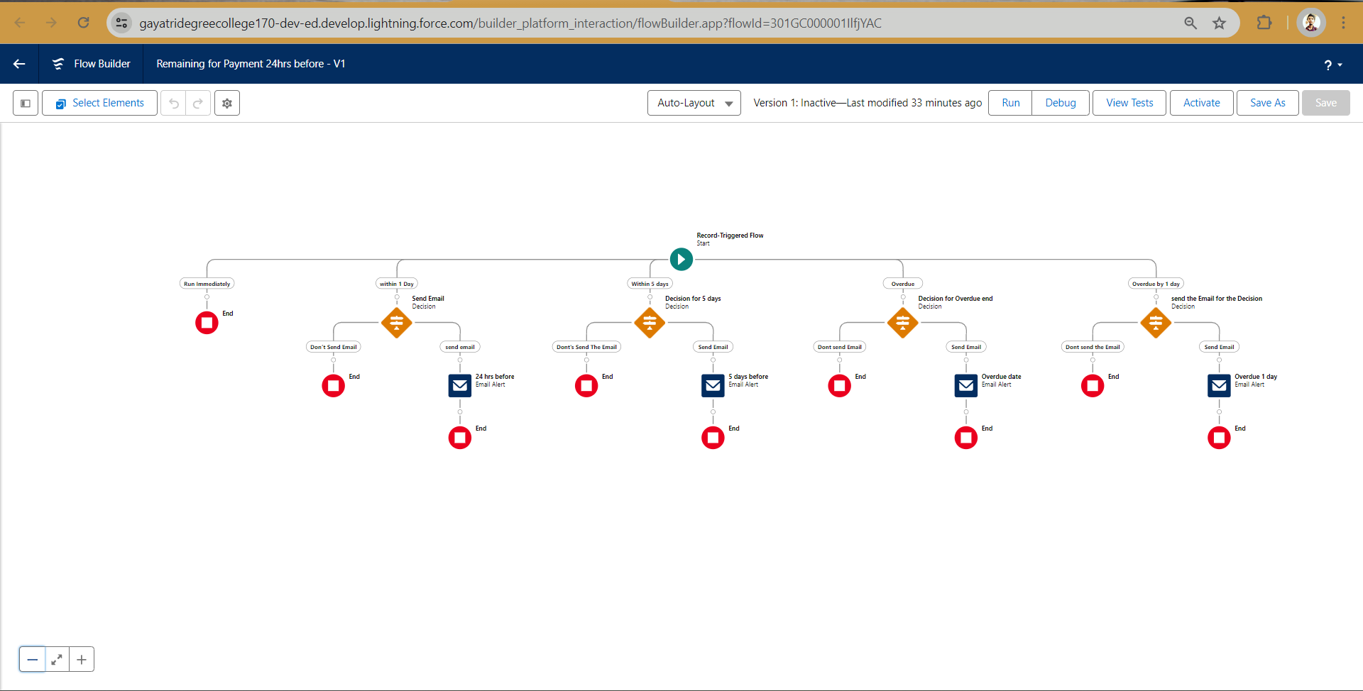

**MILESTONE-16**

**Apex Triggers**

Apex can be invoked by using triggers. Apex triggers enable you to perform custom actions

before or after changes to Salesforce records, such as insertions, updates, or deletions.

A trigger is Apex code that executes before or after the following types of operations:

insert

update

delete

merge

upsert

undelete

For example, you can have a trigger run before an object's records are inserted into the database,

after records have been deleted, or even after a record is restored from the Recycle Bin.

You can define triggers for top-level standard objects that support triggers, such as a Contact

or an Account, some standard child objects, such as a CaseComment, and custom objects. To

define a trigger, from the object management settings for the object whose triggers you want

to access, go to Triggers.

Use Case: When We Are Changing the property type form “Commercial” to “Residential” the

Than commercial field should with “Shop”

### Trigger

**Use Case:** Apex Trigger is Related  to Property Object in that there is the field “Create Property Type” which is having the picklist values in that field(Residential, Commercial, Industrial) the condition is like if we select the Create Property type as “Residential” than there is  Commercial field so it should get populated with “Shop”

**Apex Class:**

public static void propMethod(List<Property__c>propVar){

public class propClass {

    for(Property__cprop:propVar){

        if (prop.Create_Property_Type__c== 'Residential'){

            prop.Commercial__c='shop';

        }else{

        }

        }

        }

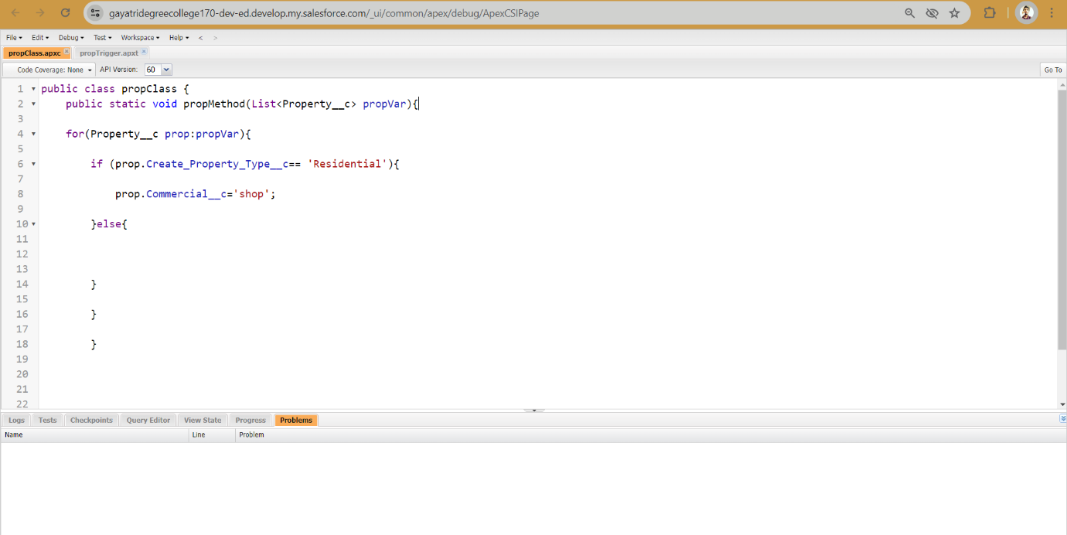

trigger propTrigger on Property__c (before update) {

    if(trigger.isUpdate){

        if(trigger.isBefore){

propClass.propMethod(trigger.new);

    }

    }

    }

* Just Go to the Property Object and Check Whether Your Trigger Is Working or not as per the requirement

